Researchers Responding to Volcanic Crises: A workshop Report

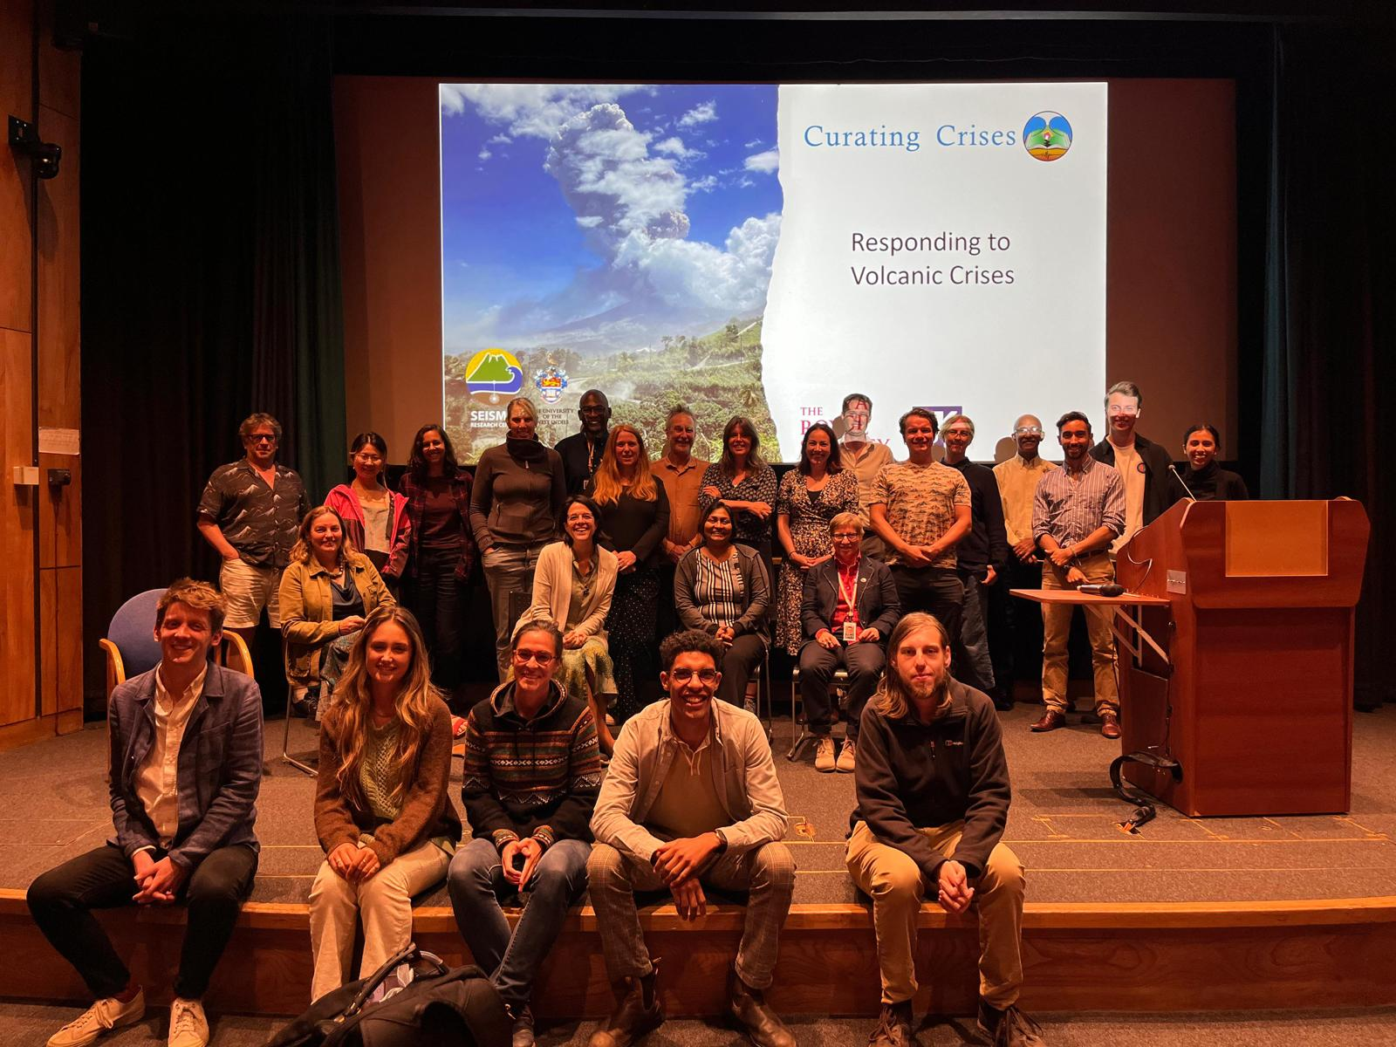
Some of our workshop participants (Photo Lara Mani).
Workshop Summary ( For VMSG newsletter): What do a poem, a map, and a suite of rocks have in common? They are all ways in which we remember and make sense of the experience of a volcanic eruption. 45 members of our community met in the John Flett Lecture theatre of the Natural History Museum on the 3rd of July to consider the various ways in which we respond to volcanic crisis, with a particular focus on the Eastern Caribbean as a case study. We began by considering the impact that colonial practices have had on the development of the research field and practises in the UK, and how we can ensure we do not reproduce these today.
We then moved on to consider present day response to crises, how we can fund research in that moment, and the various challenges that present themselves to us. Pat Joseph and Richie Robertson from SRC gave the invited lecture about their experiences responding to the 2020-2021 volcanic eruption of La Soufrière, St Vincent. In responding to a volcanic crisis it is (almost always) true that there is also a ‘crisis’ in that the eruption is exposing vulnerabilities and causing real problems for local populations. In going to a volcanic eruption site you should honestly ask of yourself the question: why are you there? During discussions the group agreed that it would be good to further consider the ethical dimensions of working in this environment, and further drill into the issues specific to different areas of volcanology, the gathering of samples, data and implicit use of resources – perhaps one for a future VMSG workshop!
The second half our discussions focussed on the profound influence on experience and perspectives that is exerted by working on and around an active volcanic system. Its perhaps why volcanologists often embrace and develop interdisciplinary ways of working and thinking. We discussed ways in which we can better support our community to gain those experiences while remaining respectful of communities at risk. The full meeting summary can be found here: [VMSG link on webpage]
Jenni Barclay, David Pyle, Teresa Armijos and Chiara Petrone.

WORKSHOP REPORT
Hidden Histories Presentations. David Pyle (Oxford), Curating Crises and Rebecca Willams (Hull), Decolonising UK Earth Sciences presented some of the relevant findings from their AHRC-NERC funded projects.
Past crises in the Eastern Caribbean were described as moments when these islands, their people and places became plugged into global scientific networks. Scientifically these were both networks of scientists, and of their instruments. In particular, scientists from the UK, USA and France descended on volcanic events and unrest, not always listening to one another and especially not to local expertise. The rush to publish dominated approaches to the gathering of data and consequently phenomena were mis-represented or overlooked, something to reflect on in the present day. The project has uncovered several excellent examples of the value of local observations and knowledge to understanding volcanic phenomena.
In Africa, geological expertise had a very strong role to play in the ‘discovery’ and exploitation of mineral resources. In Archival records or contemporary accounts the narrative emphasis is on this ‘discovery’ and the use of the heroic self in the mapping and uncovering of valuable resource minerals and metals in geological materials. However, archival photos and wider contemporary accounts demonstrate that British individuals seen as pioneers of geology made wise, but sparsely recorded use of local practices and knowledge of these resources. Across the continent many of the metals and minerals discovered were in fact already in everyday use by local populations, and much of the effort in documenting and uncovering the resources so valuable to British development was made by these local populations. The project here aims to produce materials that share this more accurate understanding of UK geologists in Africa.

Jon Stone, United Nations office for Disaster Risk Reduction then responded to these presentations with several challenges for the assembled group to consider:
In responding to a volcanic crisis it is (almost always) true that there is also a ‘crisis’ in that the eruption is exposing vulnerabilities and causing real problems for local populations. In going to a volcanic eruption site you should honestly ask of yourself the question: why are you there? And, given the benefits to you of being there how can you act in a way that shares some of these benefits. For example, can you be more supportive with the learning and consequent authorship that comes from the data? Can you operate on the site in a way that does not increase strain on those living with or responding to the crisis. [see Panel 1 below!]
For institutional and political decision-makers, in a crisis they are often seeking important insights into how to act. This is not a moment to promote or oversell your new favourite instrument or technique. Can you leverage your networks to put them in touch with the best person with that advice rather than bask in the importance of being contacted? Try to think carefully about any perception gaps emerging between what you say to them and what they think you mean. [the historical records above also documented the emergence of these understanding gaps for earlier crises].
Being immersed in a crisis can be hyper stimulating and interesting but it can also exact a mental toll on you. Can we improve how we debrief after involvement in a crisis? [see also Panel 2 below!]

Pat Joseph (SRC, Director) and Richie Robertson (SRC, geologist on ground) then lead us through an excellent analysis of the 2020-2021 example of a volcanic crisis (Soufriere, St Vincent) as a keynote. For further information and reflections see the list below.

During the Afternoon we had two excellent panel sessions
Panel 1 Funded science in crisis moments: processes, experiences and best practice.
Participating Beth Taylor, UKRI; Jane Scarrow, U Granada (La Palma eruption), Becky Williams, Hull (social media responses), Pat Joseph, SRC (local agency Soufriere, St Vincent), Chiara Petrone, NHM (Stromboli). Moderator: Jenni Barclay (UEA)
Panel began with a shared presentation from Beth Taylor of NERC UKRI, who outlined the process of applying for Urgency Grants. Projects can request up to £100K and last for a year. They are intended to create an opportunity to rapidly gather data and information that might otherwise not be captured. Volcanic eruptions are well served by this scheme, for example in the last 3 years between 12.5 and 50% of the funded projects have been focussed on eruptive events each year. For those at early career stages do reach out to VMSG members who have received funding in the past for advice!
An initial case for ‘urgency’ is assessed by NERC and if viewed positively a proposal is then submitted within 10 working days, and assessed by College Members within 4 weeks.
The value and opportunity created by this funding was warmly received and discussed. Its an excellent scheme for UK Volcanology. However there was some discussion about whether the limits to funding of the scheme encourages best practice in collaboration, and how to improve our own practices within that too. This was particularly with regard to practices in onwards stewardship of data and materials (rocks) and the publication of papers. Perhaps international collaborators such as UK funded volcanologists can take some responsibility for the sharing and curation of materials and data on behalf of busy agencies, without gatekeeping access.
The practical implications of open data sharing across settings where resources are more constrained was also discussed.
Workshop participants also discussed other ways in which funded scientists participate in and during volcanic crises, and principles for sharing of information on social media which have parallels with some of the questions posed by Jon Stone. For example, think carefully about who might see or read your post. Try not to speculate on causes, point back to the monitoring agency as much as possible. But do consider talking to your own regional media. For more discussion see:
Finally we concluded the discussion by reflecting on the need to consider the ethical implications of our research more clearly, and that volcanic crises are an important place where this ought to be done. Workshop participants had widely varying experience with Ethics Assessments and there was some discussion about whether this would be a useful workshop for VMSG to consider. Should an Ethics form be part of the Urgency Grant process?

Panel 2: The Stories We tell about Volcanoes
Alexis Keir (Vincentian Author), Richie Robertson (Vincentian Volcanologist), Jenni Barclay (UEA volcanologists), Eliza Calder (Edinburgh volcanologist). Moderator Teresa Armijos (UEA)
Each panellist began with an object and told a story of what that meant to them in the context of eruptions. Richie shared photos of himself in 1980 and 2021 to reflect on the influence that Vincentian eruptions and the experience of being of and with the community, and the impact that has had on his career.
Eliza shared the map created following the 2018 eruption of Fuego and its representation of a huge international collaborative effort to produce a new and usable map for colleagues in Guatemala. It also represented the way in which knowledge and information took on many forms, and a life of its own, once produced. Jenni shared a simple multi-function tool to represent the chaos of an eruption but also the enduring value of simple measurements during those moments. Both discussed the shift in ‘research’ perspective as a consequence of being involved in these moments.
Alexis shared a poem called ‘Me Nar Move (from Red Zone) by the Vincentian writer N.C. Marks and talked about the experience of connection and helplessness it encapsulated for him as member of the Vincentian diaspora – the chaos conveyed through piecemeal access to news about what was happening to family and friends in Saint Vincent gleaned through social media and WhatsApp groups in the absence coverage by mainstream news channels. But also, the solidarity generated as people tried to piece together information and came together in the UK and worldwide to gather resources, funds and support for those on island. He reflected on the enduring value and strength of the networks created in those responses. The panel then reflected on the value that the stories others tell them bring to their understanding of the work. Its important to listen to these stories, there is a human compulsion to engage and share via storytelling, valuable information and context can flow freely in this way. It’s a valuable resource in understanding how the natural scientific and social systems fit together to create or reduce risk.
Its also important to understand and respect who gets to tell these stories, and create environments where it possible to freely share – but its important to then relinquish control on emphasis and some of the consequences. ‘you don’t know what you are going to hear around the next corner’.
Finally we all reflected on the fact that storytelling is how humans relate to one another, there are rich opportunities to do more and better with this in the context of eruptions – not least to let scientists process and understand what they have experienced during eruptive crises themselves.

Further Reading Relevant to this workshop
Hidden Histories
Curating Crises Website and Database: https://curatingcrises.omeka.net/
Decolonising UK Earth Sciences: TBC
Rogers, S. et al., (2022) Geology Uprooted! Decolonising the Curriculum for Geologists https://gc.copernicus.org/articles/5/189/2022/
Responses to the 2020-2021 Eruption of La Soufriere, St Vincent
Joseph, E. et al., (2022) Responding to eruptive transitions during the 2020-2021 eruption of La Soufriere volcano, St Vincent, Nature Communications 13 (4129). https://www.nature.com/articles/s41467-022-31901-4
Robertson, REA et al., (Editors) The 2020-2021 Eruption of La Soufriere Volcano, St Vincent. Geological Society of London Special Volume 539. https://www.lyellcollection.org/toc/sp/539/1
Panel 1
The NERC Urgency Grant Scheme: https://www.ukri.org/opportunity/nerc-urgency-funding/
IAVCEI Guidelines for Professional Interactions during Volcanic Crises: https://www.iavceivolcano.org/iavcei/iavcei-guidelines-for-professional-interaction-during-volcanic-crises/
EDI and volcanology: Kavanagh, J. et al., (2022) Volcanologists – who are we and where are we going? Bull Volc. 84 (53) https://link.springer.com/article/10.1007/s00445-022-01547-7
Lerner, G. et al., (2023) How inclusive is volcanology? Insights from global bibliometric analyses. Volcanica 6 (1) http://www.jvolcanica.org/ojs/index.php/volcanica/article/view/173
Communication: Williams, B. and Krippner, J., (2019) The use of social media in volcano science communication: challenges and opportunities. Volcanica 1(2): https://www.jvolcanica.org/ojs/index.php/volcanica/article/view/25

Panel 2
Interview with Richie Robertson about 2021 eruption: https://www.youtube.com/watch?v=Trx72rStyaA
Alexis Keir’s Windward Family: https://www.hachette.co.uk/titles/alexis-keir/windward-family/9781909770713/
2018 Fuego Hazard Map: https://volcanichazardmaps.org/map/?id=869
Barclay, J., et al (in revision) Scientists as Storytellers: the explanatory power of stories told about environmental Crises. Natural Hazards and Earth Systems Sciences: https://egusphere.copernicus.org/preprints/2023/egusphere-2023-71/

